I go through several source file and figure out that, most of the cases we are using ‘**2 white space’** for indenting the code and we ignore ‘**Tab**’ control entry. In Visual Studio, we are frequently using ‘**Tab**’ control to indent the code. By default ‘**Tab**’ control used ‘**4 white space**’ for indenting the code.

Now, if we edit any code in VS with ‘Tab’ control entry and submit it, after then, if other developer opens the same code in other editor, he/she will view the mismatch of indentation. Which is problematic for them and sometime it causes problem during debug.

Here is the difference of same code in Visual Studio and other editor.

Example:

**Visual Studio 2010** **GVIM**

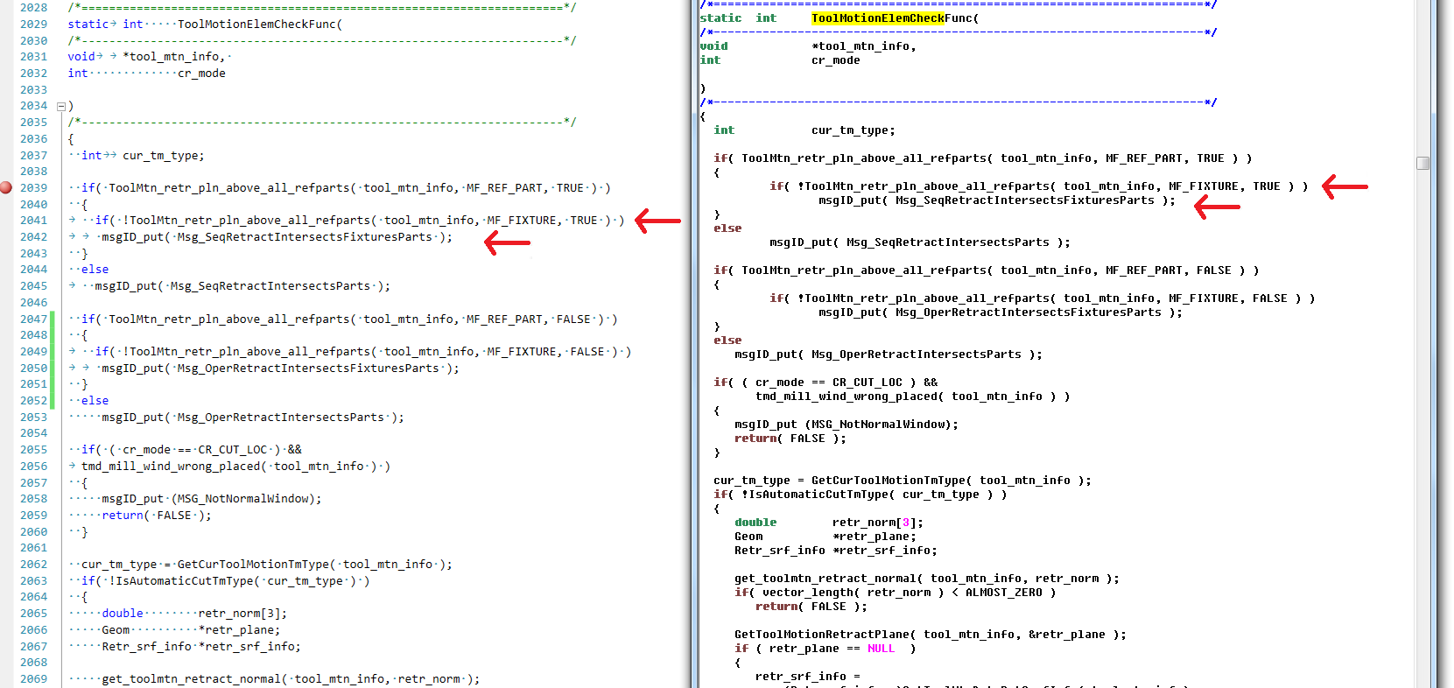

Here in Line No. 2041 and 2042, you will find the white space difference.

* Visual Studio provides the facility to replace ‘**Tab**’ control by ‘**white space’** which helps us to reduce the white space problem in other editor(s). Here is the process:
  + ***View White Space in Visual Studio:***

In VS Menu, Go to ‘**Edit** -> **Advanced** –> **View White Space**’ and click on this option.

OR

Press: **Ctrl+R**, **Ctrl+W**

* + ***Replace ‘Tab’ control by ‘White Space’:***

1. In VS Menu, Go to ‘**Tools** -> **Options…**’ and click on it.
2. ‘**Option**’ dialog will arise.
3. Select ‘**Text Editor** -> **All Languages** -> **Tabs**’ from Tree view of the Left panel.
4. Put ‘**2**’ in ‘**Tab size**’ & ‘**Indent size**’ input box.
5. Select ‘**Insert spaces**’ radio option.
6. Finally click ‘**OK**’ button to save the changes.
   * ***Final ‘Option’ dialog will look like:***

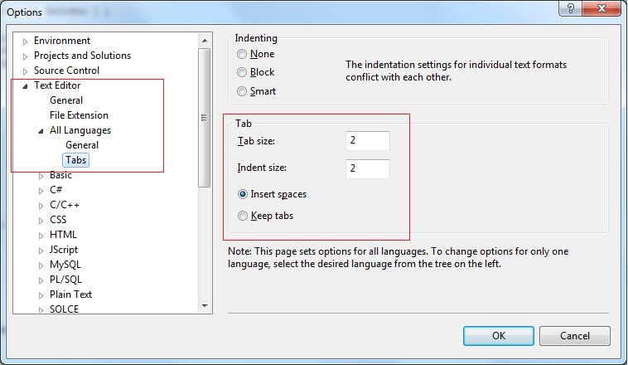

Now, if you press ‘**Tab**’ control for indentation, each ‘Tab’ control will be replaced by ‘**2 white space(s)’.**

* You can adjust number of white space(s) by replacing the value of ‘**Tab size**’ and ‘**Indent size**’ input box.

After these changes you will find similar view of the above code in different editor:

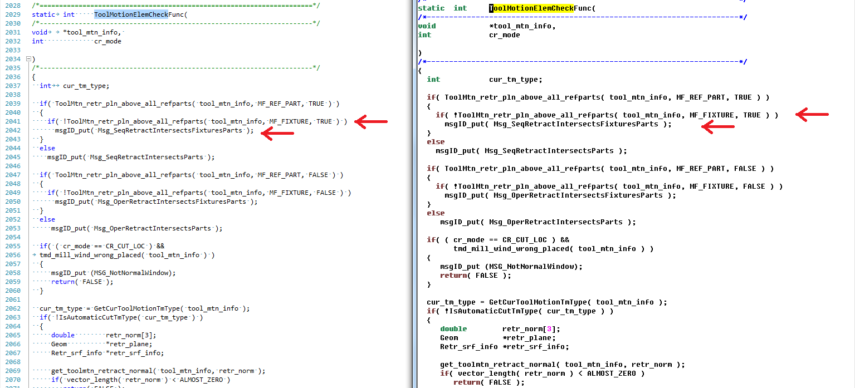

Links:

<http://msdn.microsoft.com/en-us/library/7sffa753.aspx>

<http://stackoverflow.com/questions/14167033/visual-studio-2010-replace-tab-with-4-spaces>

<http://social.msdn.microsoft.com/Forums/en-US/968c0388-0f5d-4291-92db-fc67580ed347/formatting-marks-in-vs-editor?forum=vstsstart>

<http://vim.wikia.com/wiki/Converting_tabs_to_spaces>

**N.B.: All the steps are taken from Visual Studio 2010.**